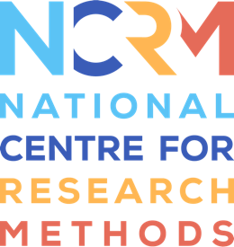
Storytelling Toolkit

Activity 1 – Collect and Connect

So the first activity is called Collect and Connect. So if you're going to be doing any kind of object based methods, then obviously you're going to need some objects. So the purpose of this is really get you thinking about where you can source your objects from. So there's lots of places you can source objects from at a reasonable price or, of course free. So you can use your personal network, if you're looking to borrow things, you can go on kind of social media sites, or specific groups, or a favourite of mine is to use a car boot sale, or there's lots of objects, they're very reasonably priced. But another way you can do it is by getting people to bring their own objects along. So if you have a group, you can get people to bring objects along. And one way to do it is through the activity here outlined in collecting connect.
It's an opportunity for people really to think about what might be good objects to bring along. And so you can get people in your group to talk about an object that they brought along. Now a top tip is if they haven't remembered to bring an object, which often does happen, you can get them to talk about something on them. So about something in their bag, their keys, their phone, and I've done this myself, and it's really productive, because people have lots of things to say, then what you can do is get people to discuss the objects I've talked about, think about, what would it be really good, what would have been a great object for us to talk about here. And that's then the occasion for people to be kind of inspired about what sorts of objects they might want to bring along.
This is a great activity for you to generate discussions or ideas of what objects you can use to bring along for future storytelling sessions. And also just really getting creative discussions going and for people to realize, actually, there's a lot of potential for these object based methods. You're also giving people ownership of what objects they can bring along. And just kind of thing to remember is that it's brilliant way to get people to bring along their own objects, but always remember, some people will forget. So you're going to have to make sure you've got some additional spares that you're prepared with. But otherwise, I think you'll find this a great introductory opportunity to stop thinking about where you're going to get your objects from.

National Centre for Research Methods (NCRM)
Social Sciences
Murray Building (Bldg 58)
University of Southampton
Southampton SO17 1BJ
United Kingdom
Web www.ncrm.ac.uk
Email info@ncrm.ac.uk
Tel +44 23 8059 4539
Twitter @NCRMUK

